Drone Server

Drone is a Continuous Delivery system built on container technology and written in Go. It uses a simple configuration yaml, with syntax similar to a docker-compose file, to define and execute pipelines inside Docker containers.

For our test case, we set up a Drone build server, running on an AWS EC2 instance, which connects to our (private) GitHub repository and builds and tests the code after each commit.

Setup EC2 instance

We launched an EC2 instance with the default AWS Linux image into a public subnet with a security group open for the following tcp ports: 22, 80, 443, 9418 and 8000.

Instance ID - i-0d2eb0699467cf418
Public DNS (Ipv4) - ec2-35-182-51-140.ca-central-1.compute.amazonaws.com
IPv4 Public IP - 35.182.51.140
Key pair name - WorklandDroneKeyM ( location of the key - /home/workland/Desktop/WorklandDroneKeyM.pem – Workland-server computer)

Next, we ssh in using the following command:

ssh -i Desktop/WorklandDroneKeyM.pem ec2-user@ec2-35-182-51-140.ca-central-1.compute.amazonaws.com

Because Drone is built on container technology, we have installed Docker and Docker-Compose on our EC2 instance folowing the next steps:

sudo yum update -y
sudo yum install -y docker
sudo service docker start
sudo usermod -a -G docker ec2-user (Add the ec2-user to the docker group so you can execute Docker commands without using sudo.)

Afterwards, we continued the installation process with docker-compose.

sudo curl -L "https://github.com/docker/compose/releases/download/1.18.0/docker-compose-$(uname -s)-$(uname -m)" > /usr/local/bin/docker-compose
sudo chmod +x /usr/local/bin/docker-compose
exit
docker-compose —version

GitHub OAuth consumer
In order to monitor code changes to trigger build and test stages, Drone will need access to your source code repository. Drone can integrate with GitHub, GitLab, Gogs, Bitbucket Cloud, and Bitbucket Server.
We created a new OAuth consumer with a callback URL, to enable Drone to connect to our repositories.
In your GitHub account, go to Settings —> Developer settings —> OAuth Apps —> New OAuth App or Register a new application (in case you don’t have any old applications).

Fill in the form with sensible information:
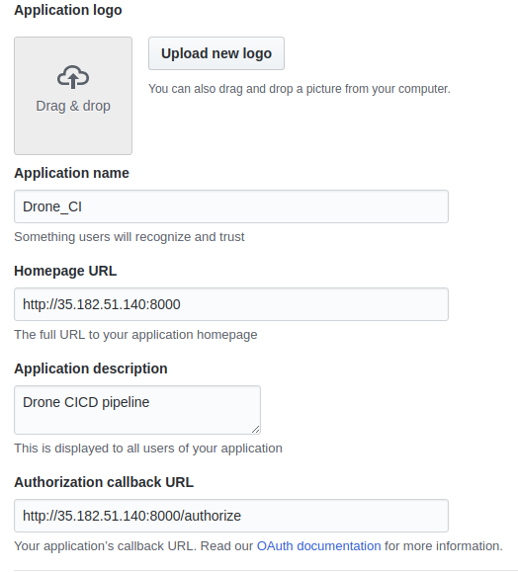

Where,

Application name: A name you choose to identify the integration.
Homepage URL: Your Drone server's domain name or IP address.
Application description: A simple description of Drone and it's purpose.
Authorization callback URL: This must be the http:// schema specifier, followed by your Drone server's domain name or IP address, followed by /authorize.

After you click the Register application, on the following page, you will see the details for your new application. The two items we need are the Client ID and the Client Secret.

Pull the Drone Docker Image and Prepare for Configuration

Drone is distributed as a Docker container, so it will be automatically downloaded if we use it in a Docker Compose file. To speed up the process slightly though, we can pull down the image ahead of time:

docker pull drone/drone:0.8.4

The Drone Docker image is a unified container that can be run in a few different ways. We will run one container that operates as the Drone server, which coordinates repository access, hosts the web UI, and serves the API. Using the same image with different settings, we will run another container as a Drone agent, which is responsible for building and testing software from the configured repositories.

We will run both of these containers on the Drone host using Docker Compose. The next step is to provide a docker-compose file on the EC2 instance, which will start the Drone server and the Drone agent.

The drone-server service will start the main Drone server container listening on port 8000.

The drone-agent service uses the same image, started with the agent command. It receives instructions from the main Drone server instance, so while it does not need general network access, it does need to be started after the Drone service. It also needs access to Docker's socket file to spin up containers to run the actual build and test steps. Like the drone-server service, this service will also automatically restart.

On the EC2 instance terminal session, we created a docker-compose.yml file:

nano docker-compose.yml

with the following content:

version: '3'

services:
drone-server:
image: drone/drone:0.8.4
ports:
- 8000:8000
- 9000:9000
volumes:
- ./drone:/var/lib/drone/
restart: always
environment:
- DRONE_OPEN=true
- DOCKER_API_VERSION=1.26
- DRONE_HOST=http://35.182.51.140
- DRONE_SECRET=62TDlYswq5erw6jqVnp/ya6gfYmRFgihH5hCWYQuhgw
- DRONE_ADMIN=<GitHub account name>
- DRONE_GITHUB=true
- DRONE_GITHUB_CLIENT=2b721ed065a5cfb0904a
- DRONE_GITHUB_SECRET=2e2d4a964a1e3374e1ce56682252683bfdbb0cf9

drone-agent:
image: drone/agent:0.8.4
restart: always
depends_on:
- drone-server
volumes:
- /var/run/docker.sock:/var/run/docker.sock
environment:
- DOCKER_API_VERSION=1.26
- DRONE_SERVER=drone-server:9000
- DRONE_SECRET=62TDlYswq5erw6jqVnp/ya6gfYmRFgihH5hCWYQuhgw

Where,

image: drone/drone:0.8.4
– consult the drone.io documentation - http://docs.drone.io/installation to check the latest release

volumes:
- ./drone:/var/lib/drone/
- Drone mounts a volume on the host machine to persist the sqlite database;

environment:
- Inside, we have to define the environment variables that Drone uses to connect to bind start the service, connect to the repository provider, and set account authorization policies:

- DRONE_OPEN=true
this is the configuration of the integration with our VCS provider, which is GitHub in our case.
Drone provides multiple configurations for open or limited access to the system.
The value may be set to <true> or to <false> depending on our needs.
<false> means that only the GitHub account names specified in DRONE_ADMIN will be able to log in, <true> - any account.

- DRONE_ADMIN=<GitHub account name>
In our case we work with collaborators as a GitHub organization, so it is better to set DRONE_OPEN to true and replace DRONE_ADMIN with DRONE_ORGS. The DRONE_ORGS setting allows you to specify one or more GitHub organizations whose members should be allowed register. Drone will limit registration to users who belong to those groups.

- DRONE_GITHUB=true
activates the GitHub integration plugin

- DRONE_GITHUB_CLIENT=2b721ed065a5cfb0904a
- DRONE_GITHUB_SECRET=2e2d4a964a1e3374e1ce56682252683bfdbb0cf9
the keys we copied from the GitHub OAuth application page when we registered our Drone application.

- DRONE_HOST=http://35.182.51.140
Drone needs to know its own address. You must therefore provide the address in <scheme>://<hostname> format. Please omit trailing slashes.

- DRONE_SECRET=62TDlYswq5erw6jqVnp/ya6gfYmRFgihH5hCWYQuhgw
This is a key to authenticate the agent and server components. Although our setup has both of these components on the same server, as our testing infrastructure scales out, a strong key is essential. You can use an arbitrary value as DRONE_SECRET, in our case we generated one with the following command:
openssl rand -base64 32

http://docs.drone.io/install-for-github/

drone-agent:
volumes:
- /var/run/docker.sock:/var/run/docker.sock
Drone agents require access to the host machine Docker daemon.

environment:
- DRONE_SERVER=drone-server:9000
Drone agents require access to the host machine Docker daemon.
- DRONE_SECRET=62TDlYswq5erw6jqVnp/ya6gfYmRFgihH5hCWYQuhgw
This key must match the DRONE_SECRET specified for the drone-server.

After the configuration of the docker-compose.yml file, we started the stack with the command:
docker-compose up

Log into Drone To Authorize Access to Your Repository

Now that Drone is up and running, we can log into the web interface and authorize the application to use our GitHub account.

Visit your server's domain name in your web browser to view the Drone web interface at:
http://[public-ip-of-ec2-instance]:8000

